PRACTICAL NO.11
a. Programming Media API and Telephone API
Code:
activity_main.xml
<?xml version="1.0" encoding="utf-8"?>
<androidx.constraintlayout.widget.ConstraintLayout xmlns:android="http://schemas.android.com/apk/res/android"
xmlns:app="http://schemas.android.com/apk/res-auto"
xmlns:tools="http://schemas.android.com/tools"
android:layout_width="match_parent"
android:layout_height="match_parent"
tools:context=".MainActivity">
<Button
android:id="@+id/button"
android:layout_width="wrap_content"
android:layout_height="wrap_content"
android:text="Play"
app:layout_constraintBottom_toBottomOf="parent"
app:layout_constraintEnd_toEndOf="parent"
app:layout_constraintHorizontal_bias="0.3"
app:layout_constraintStart_toStartOf="parent"
app:layout_constraintTop_toTopOf="parent"
app:layout_constraintVertical_bias="0.13" />
<Button
android:id="@+id/button2"
android:layout_width="wrap_content"
android:layout_height="wrap_content"
android:text="Pause"
app:layout_constraintBottom_toBottomOf="parent"
app:layout_constraintEnd_toEndOf="parent"
app:layout_constraintHorizontal_bias="0.749"
app:layout_constraintStart_toStartOf="parent"
app:layout_constraintTop_toTopOf="parent"
app:layout_constraintVertical_bias="0.13" />
<SeekBar
android:id="@+id/seekBar"
android:layout_width="0dp"
android:layout_height="wrap_content"
android:layout_marginStart="32dp"
android:layout_marginEnd="32dp"
app:layout_constraintBottom_toBottomOf="parent"
app:layout_constraintEnd_toEndOf="parent"
app:layout_constraintHorizontal_bias="0.0"
app:layout_constraintStart_toStartOf="parent"
app:layout_constraintTop_toTopOf="parent"
app:layout_constraintVertical_bias="0.057" />
<VideoView
android:id="@+id/videoView"
android:layout_width="0dp"
android:layout_height="200dp"
android:layout_marginStart="24dp"
android:layout_marginEnd="24dp"
app:layout_constraintBottom_toBottomOf="parent"
app:layout_constraintEnd_toEndOf="parent"
app:layout_constraintHorizontal_bias="0.0"
app:layout_constraintStart_toStartOf="parent"
app:layout_constraintTop_toTopOf="parent"
app:layout_constraintVertical_bias="0.323" />
<Button
android:id="@+id/button3"
android:layout_width="wrap_content"
android:layout_height="wrap_content"
android:text="Call Now"
app:layout_constraintBottom_toBottomOf="parent"
app:layout_constraintEnd_toEndOf="parent"
app:layout_constraintHorizontal_bias="0.498"
app:layout_constraintStart_toStartOf="parent"
app:layout_constraintTop_toTopOf="parent"
app:layout_constraintVertical_bias="0.708" />
</androidx.constraintlayout.widget.ConstraintLayout>

MainActivity.kt
package com.example.playground
class MainActivity : AppCompatActivity() {
override fun onCreate(savedInstanceState: Bundle?) {
super.onCreate(savedInstanceState)
setContentView(R.layout.activity_main)
var mc:MediaPlayer= MediaPlayer.create(this,R.raw.ram)
button.setOnClickListener {
mc.start()
}
button2.setOnClickListener {
mc.stop()
}
seekBar.max=mc.duration
seekBar.setOnSeekBarChangeListener(object :SeekBar.OnSeekBarChangeListener{
override fun onProgressChanged(p0: SeekBar?, p1: Int, p2: Boolean) {
if (p2){
mc.seekTo(p1)
}
}
override fun onStartTrackingTouch(p0: SeekBar?) {
}
override fun onStopTrackingTouch(p0: SeekBar?) {
}
})
var videoFilePath="android.resource://com.example.playground/raw/"+R.raw.newvideo
videoView.setVideoURI(Uri.parse(videoFilePath))
videoView.setMediaController(MediaController(this))
videoView.start()
button3.setOnClickListener {
var call=Intent(Intent.ACTION_CALL)
call.setData(Uri.parse("tel:+91 8275668266"))
startActivity(call)
}
}
}

Add This Line at AndroidManifest.xml :
<uses-permission android:name="android.permission.CALL_PHONE"></uses-permission>

Output:

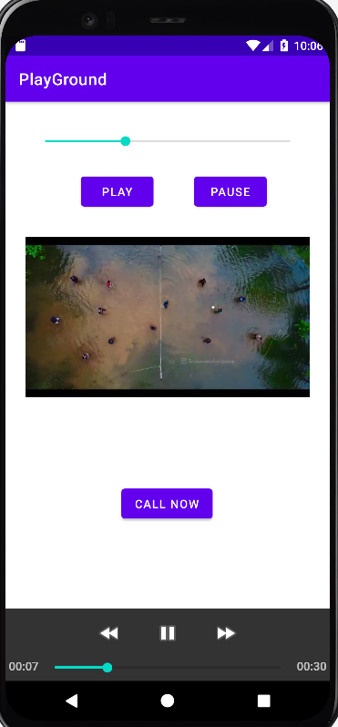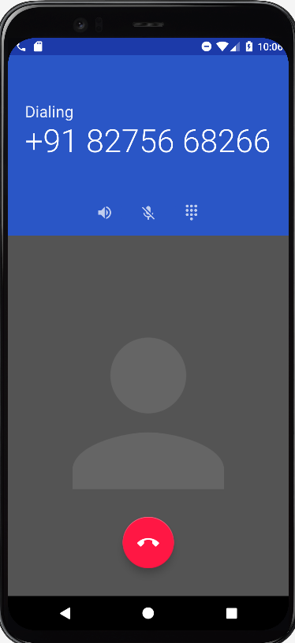

b. Programming Security and permissions
Code:
activity_main.xml
<?xml version="1.0" encoding="utf-8"?>
<androidx.constraintlayout.widget.ConstraintLayout xmlns:android="http://schemas.android.com/apk/res/android"
xmlns:app="http://schemas.android.com/apk/res-auto"
xmlns:tools="http://schemas.android.com/tools"
android:layout_width="match_parent"
android:layout_height="match_parent"
tools:context=".MainActivity">
<Button
android:id="@+id/button"
android:layout_width="wrap_content"
android:layout_height="wrap_content"
android:text="Request Permission"
app:layout_constraintBottom_toBottomOf="parent"
app:layout_constraintEnd_toEndOf="parent"
app:layout_constraintStart_toStartOf="parent"
app:layout_constraintTop_toTopOf="parent"
app:layout_constraintVertical_bias="0.257" />
</androidx.constraintlayout.widget.ConstraintLayout>

MainActivity.kt
package com.example.permissionpract
class MainActivity : AppCompatActivity() {
override fun onCreate(savedInstanceState: Bundle?) {
super.onCreate(savedInstanceState)
setContentView(R.layout.activity_main)
button.setOnClickListener {
ActivityCompat.requestPermissions(this, arrayOf(Manifest.permission.CAMERA,Manifest.permission.READ_CONTACTS,Manifest.permission.READ_EXTERNAL_STORAGE,Manifest.permission.CALL_PHONE,Manifest.permission.READ_CALENDAR,Manifest.permission.READ_SMS),1)
}
}
override fun onRequestPermissionsResult(
requestCode: Int,
permissions: Array<out String>,
grantResults: IntArray
) {
if (grantResults.size > 0 && grantResults[0] == PackageManager.PERMISSION_GRANTED)
{
Toast.makeText(this,"All Permission Granted!!!",Toast.LENGTH_SHORT).show()
}
else{
Toast.makeText(this,"Permission Denied!!!",Toast.LENGTH_SHORT).show()
}
super.onRequestPermissionsResult(requestCode, permissions, grantResults)
}
}

AndroidManifest.xml:
<?xml version="1.0" encoding="utf-8"?>
<manifest xmlns:android="http://schemas.android.com/apk/res/android"
xmlns:tools="http://schemas.android.com/tools"
package="com.example.permissionpract">
<uses-permission android:name="android.permission.CAMERA"/>
<uses-permission android:name="android.permission.READ_CONTACTS"/>
<uses-permission android:name="android.permission.READ_EXTERNAL_STORAGE"/>
<uses-permission android:name="android.permission.CALL_PHONE"/>
<uses-permission android:name="android.permission.READ_CALENDAR"/>
<uses-permission android:name="android.permission.READ_SMS"/>
<application
android:allowBackup="true"
android:dataExtractionRules="@xml/data_extraction_rules"
android:fullBackupContent="@xml/backup_rules"
android:icon="@mipmap/ic_launcher"
android:label="@string/app_name"
android:roundIcon="@mipmap/ic_launcher_round"
android:supportsRtl="true"
android:theme="@style/Theme.PermissionPract"
tools:targetApi="31">
<activity
android:name=".MainActivity"
android:exported="true">
<intent-filter>
<action android:name="android.intent.action.MAIN" />
<category android:name="android.intent.category.LAUNCHER" />
</intent-filter>
</activity>
</application>
</manifest>

Output:

